KEYNOTE ADDRESS

Dr. Cho, Taehwan, Chairman of the Korea Aviation and Railway Accident Investigation Board(KARAIB),

Good morning. Thank you very much Mr. Ron Schleede, Mr. Marcus De Costa, and Mr. President Frank Del Gandio and others that made it possible for me to speak today to the distinguished delegates from all over the world. I feel much honored and privileged. I am standing here on behalf of Dr. Cho, Taehwan, Chairman of the Korea Aviation and Railway Accident Investigation Board(KARAIB), who sends his sincere regrets that he could not attend as scheduled. He also sends his strong support to ISASI for the success of this 44th annual seminar.
Chairman Dr.Cho specially asked that I express his thanks and the thanks of the entire aviation industry in Korea to ISASI for its support in connection with the ISASI Reachout Workshop conducted in April 2013, for that 52 participants from 9 States in Asia Pacific region attended along with several student observers. The responses were overwhelming that many other people wanted to attend while could not be accommodated. The instructors were most dedicated and selfless Mr.Ron Schleede, Mr.Toby Carroll, and Mr. Curt Lewis. The reason why I am saying this is that as we all know, the instructors do not get paid by conducting an ISASI Reachout Workshop, as it is purely a voluntary work to enhance the aviation safety in that particular region
I would now like to provide you a brief overview of the government structure for aviation safety in Korea. All the aviation safety related agencies are affiliated with the The Ministry of Land, Infrastructure and Transport(MLIT) that oversees transportation safety in Korea. The aviation regulatory body is named the Civil Aviation Office, and the building is located in the Government Complex, Sejong City situated at the central part of South Korea. You might be yet unfamiliar with the city name-Sejong, as it is the city newly created and intentionally planned for the government administration such as Washington D.C. or Canberra in Australia
The KARAIB is affiliated with the MLIT, still it is the independent accident and incident investigation Board for aviation and railroad in Korea, as it is clearly prescribed in the corresponding law that the minister, other than administrative purposes, shall not interfere with investigation activities conducted by the Board.
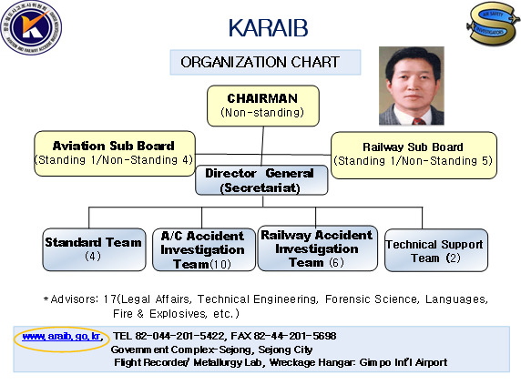

As for the organization of the KARAIB, we have a Chairman(non-standing), two sub-boards of aviation and railway respectively, and a secretariat led by a Director General, under his leadership, there are four teams of standard, aircraft accident investigation, railway accident investigation and technical support. In addition, there are 17 advisors by expertise area of legal affairs, technical engineering, forensic science, languages, fire and explosives, etc. The office is also located in Sejong City while the flight recorder/metallurgy lab and wreckage hanger are within the area of the Gimpo International Airport, Seoul.
Regarding the history of the KARAIB, the start was feeble, as they say, with two aircraft accident investigation officers appointed in 1990, which means that they were tasked with other main duties if there was no accident taken place. Then in 2001, we were rated category 2 by the result of the FAA IASA, and it was a real difficult time for the Korea aviation community, but it was a disguised blessing that the government aviation structure was rapidly expanded in a short time period to that of these days. Through this opportunity, in 2002, the Korea Aviation Accident Investigation Board was established with 7 Board members and 17 investigators. And in 2006, the railway sector was integrated that the Korea Aviation and Railway Accident Investigation Board was emerged with 12 Board members and 26 investigators.

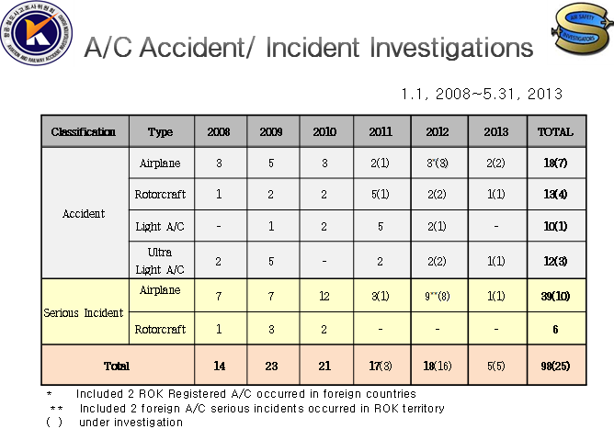

Coming to the Board’s investigation activities, during 5 and half year time, there were 18 accidents to airplanes(7 cases are still under investigation) and 13 to rotorcraft(4 under investigation). 39 serious incidents to airplanes(10 under investigation).

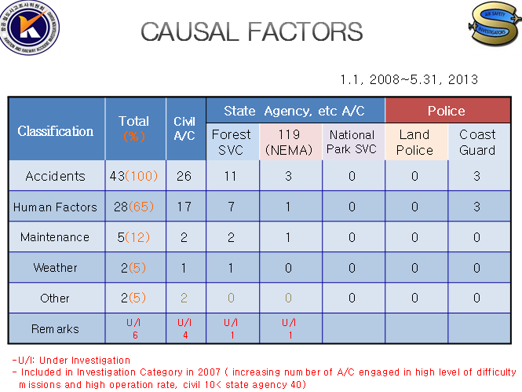
And if I may, I am going to state a special feature of the Board’s investigation activities. We have an increasing number of State Agency aircraft, so is their accident rate, which has become an public issue. With this in the background, the Board has included the State Agency aircraft accidents in the investigation scope since 2007. In terms of causal factors, like in civil aircraft accidents elsewhere in the world, human factors has been the primary factor. And let me show you some of the civil accident aircraft photos.
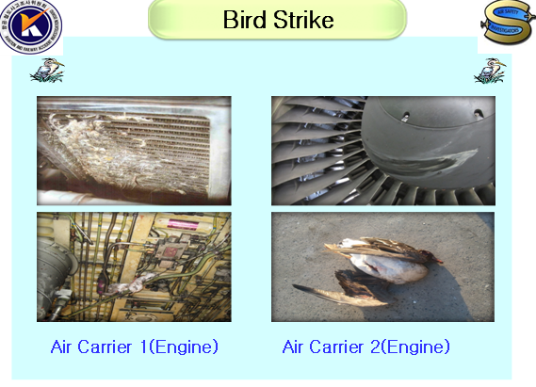
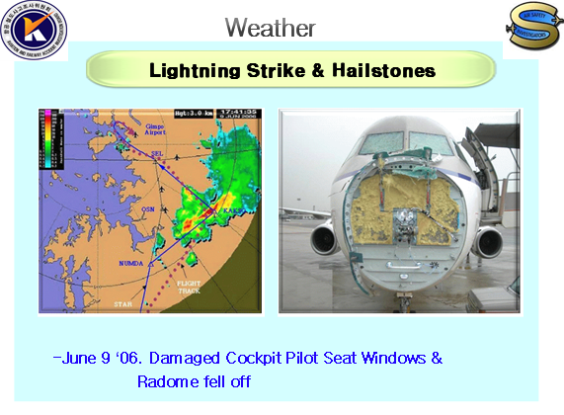
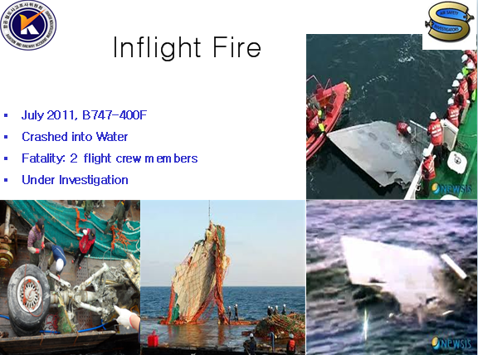

Concerning the effort to promote investigation quality, for your better understanding, I’d better mention the ICAO USOAP conducted for Korea in 2000 in association with Annexes 1, 6, 8 to the Convention on International Civil Aviation. Then our compliance rate was shown low-below 80%, and as stated in the beginning, soon after in 2001, we were rated category 2 by the FAA. Within about 4 year time period until the next comprehensive ICAO USOAP in 2005, the will and extensive efforts of both government sector and air carriers to get the Korea aviation safety on the right track were evident tin every side which needed to be fixed. At the same time, the aviation safety professionals recognized worldwide for their aviation safety expertise were willing to guide and help, worked together us with all their hearts, for example, Mr.Schleede is one of them who has been assisting and unsparingly sharing his knowledge and experiences from the stages of 007 accident, Guam accident, Gimhae accident, ICAO USOAP, ISASI Reachout Workshop, etc. up to this time. Eventually in 2005, the result of the ICAO USOAP showed that our compliance rate was 98.82% with almost no findings, which happened to be the best outcome among 191 ICAO contracting States. Having seen these changes, I firmly believe that aviation safety community is one, borderless, and in this aspect, this ISASI annual seminar is such a valuable means to get us united as one.
In relation with ISASI, before the ISASI Reachout Workshop held this April, we had two corporate members of Air Force and KARAIB and one individual member in Korea. On the last day of the workshop, 40 some people were lined up to sign the application form. Following the success of the workshop, we had a KSASI formation meeting this June, and officers were selected through an election, the Board Chairman Dr. Cho the president, the aircraft accident team director Mr.Park the vice president, and myself secretary and treasurer. I hope that you will continuously encourage and support us, and we will be able to show more remarkable progress in the next annual seminar.

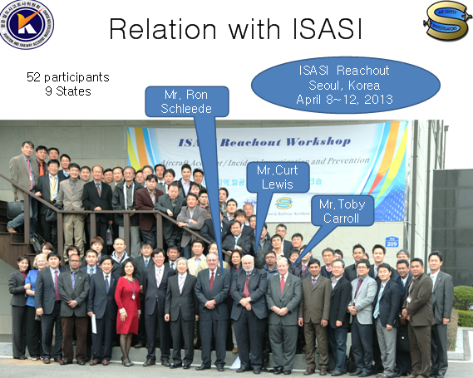
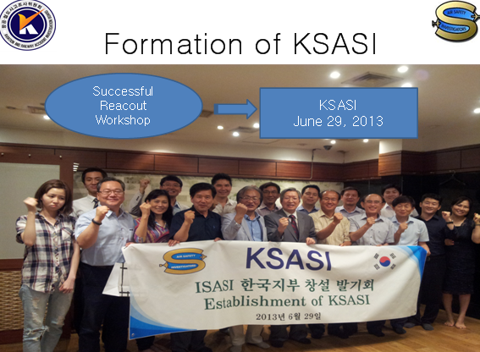
As I am about to close my presentation, once again, I would like to extend the special thanks to each one of you from the Board Chairman Dr.Cho and all the members of Korea aviation safety community. As for myself, thank you very much for your attention, and God bless you. Thank you.

